Composite Solids Formed by Subtraction
# Source: AI Source: Provided by: [Data Path: Persons Table -> ID Column: 1, Name_En Column: Motasem Essam] -> From: [ChatGPT] on [7/25/2026]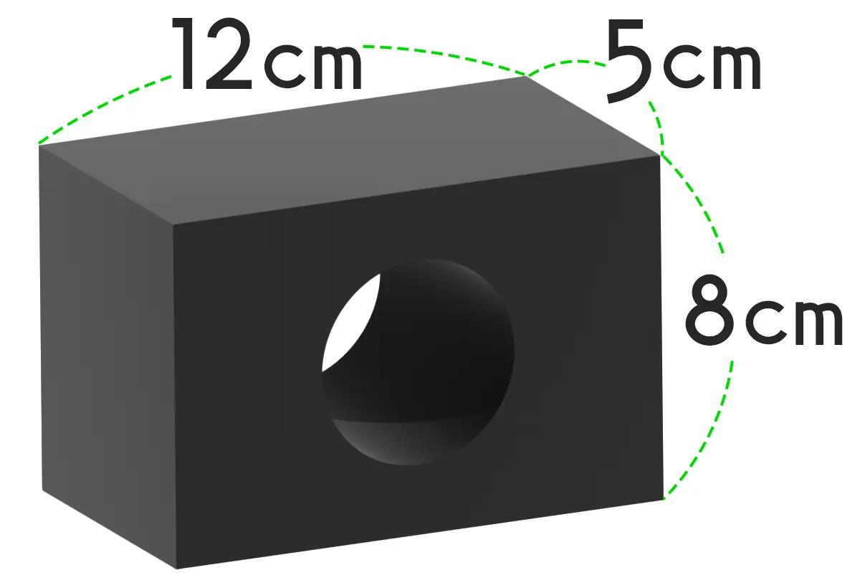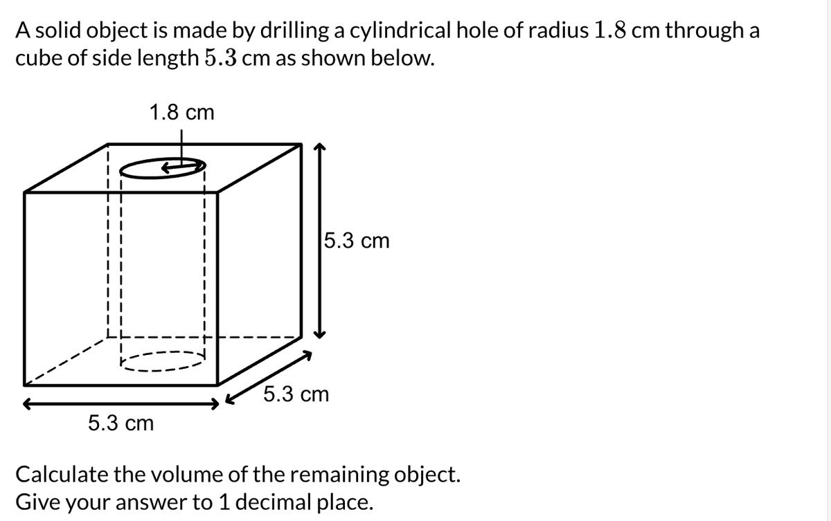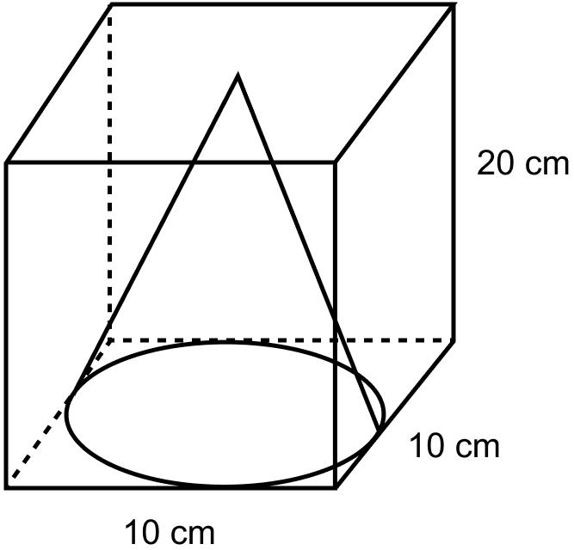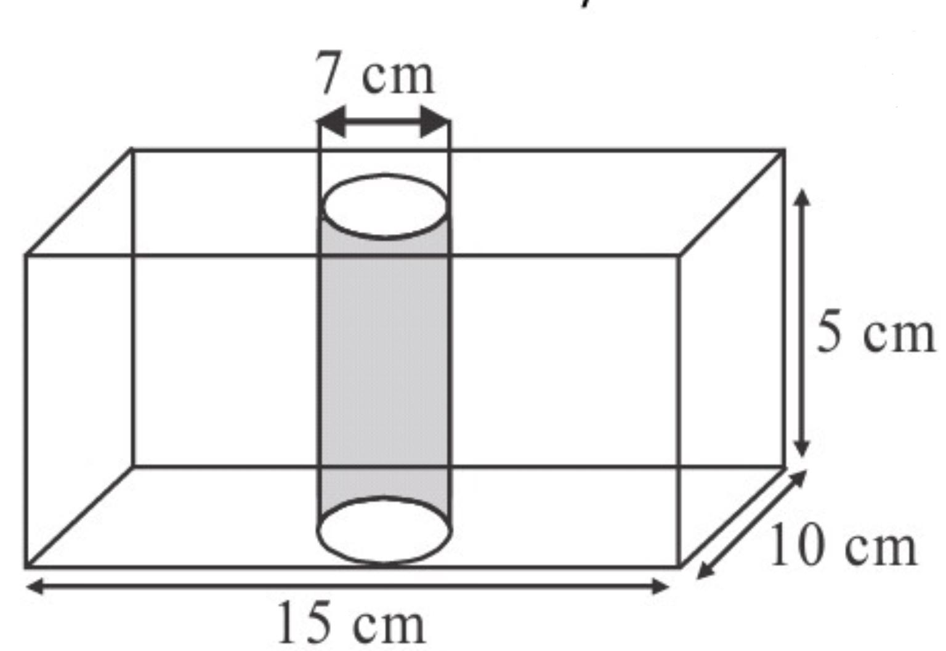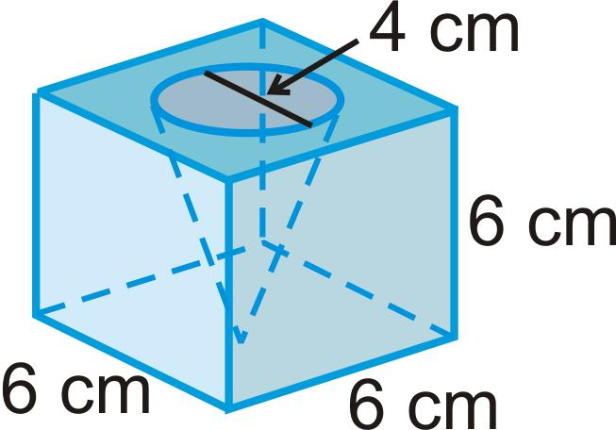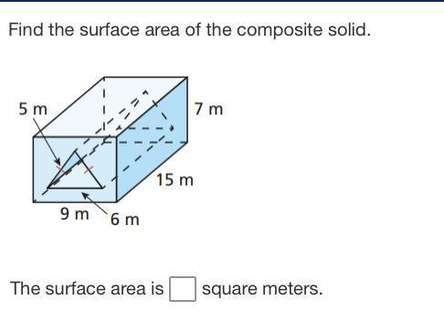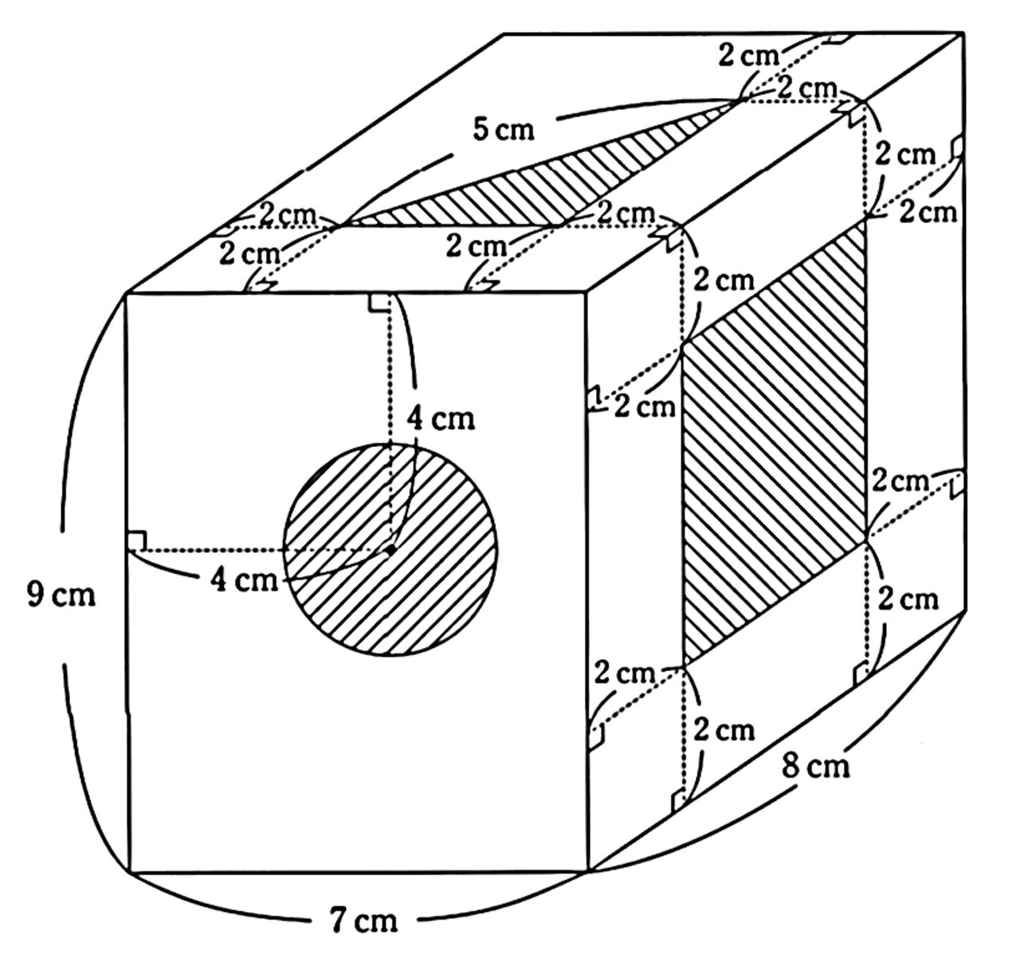

Definition
# Source: AI Source: Provided by: [Data Path: Persons Table -> ID Column: 1, Name_En Column: Motasem Essam] -> From: [ChatGPT] on [7/25/2026]
Composite solids formed by subtraction are three-dimensional geometric objects created by removing one or more portions of a basic solid or composite solid.
The removed portions may have regular geometric shapes, such as cylinders, cones, spheres, prisms, or pyramids.
This construction is also known as subtractive solid composition or solid subtraction.
Examples include:
- A rectangular prism with a cylindrical hole.
- A cube with a spherical cavity.
- A cylinder with a conical section removed.
- A solid block with multiple rectangular cutouts.

Simple Definition
# Source: AI Source: Provided by: [Data Path: Persons Table -> ID Column: 1, Name_En Column: Motasem Essam] -> From: [ChatGPT] on [7/25/2026]
A composite solid formed by subtraction is a 3D shape created by cutting or removing parts from an existing solid.
Its remaining volume is calculated by subtracting the removed volumes from the original volume, accounting for any overlapping removed regions.

Geometric Representation
# Source: AI Source: Provided by: [Data Path: Persons Table -> ID Column: 1, Name_En Column: Motasem Essam] -> From: [ChatGPT] on [7/25/2026]
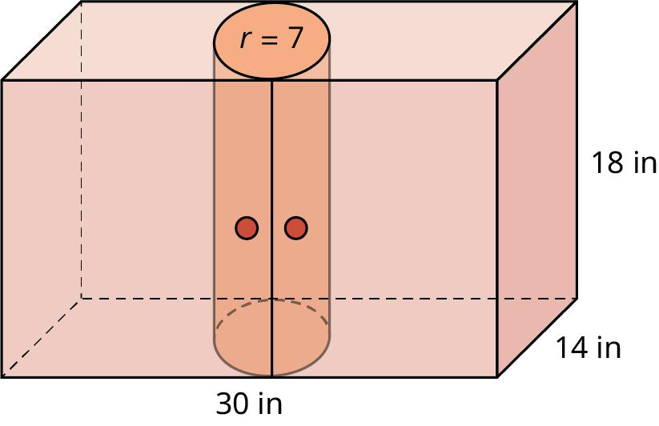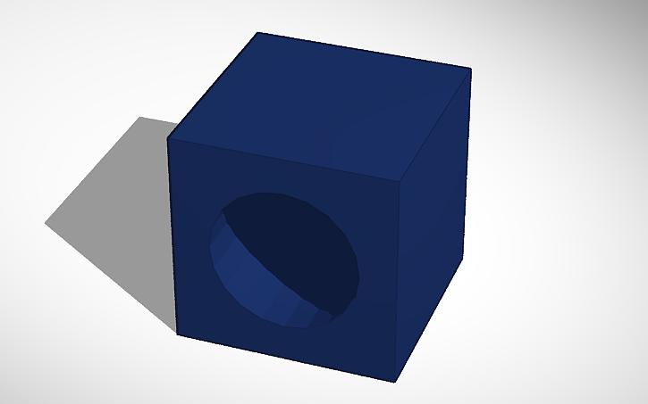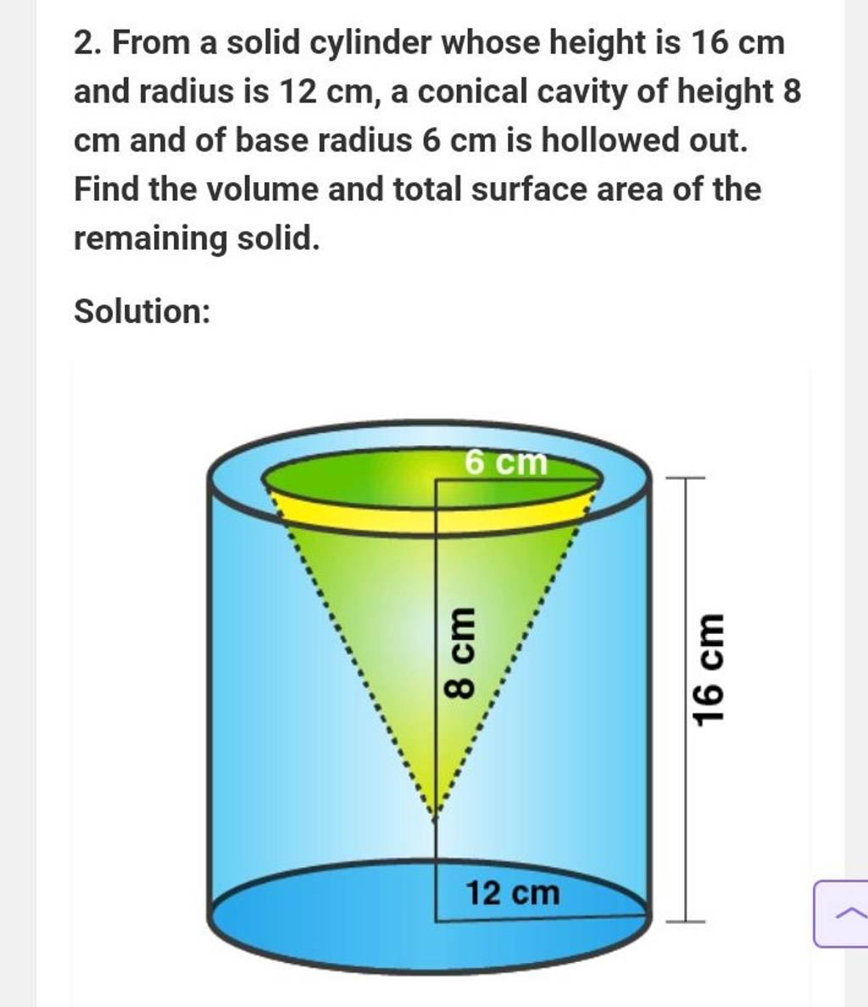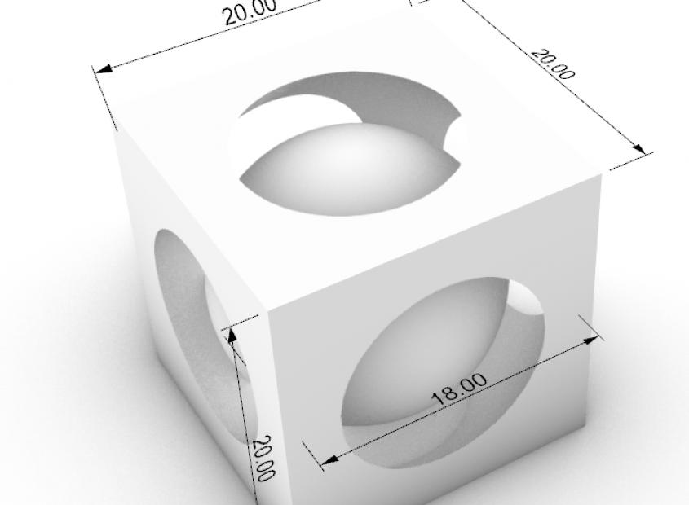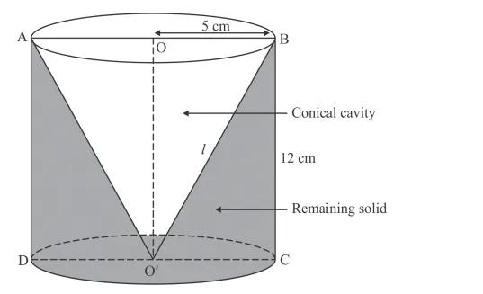
A composite solid formed by subtraction consists of several geometric elements:
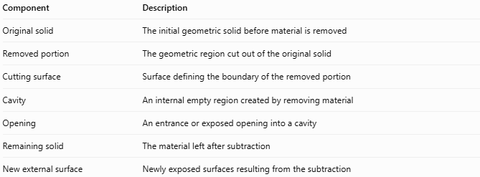
Component | Description
Original solid | The initial geometric solid before material is removed
Removed portion | The geometric region cut out of the original solid
Cutting surface | Surface defining the boundary of the removed portion
Cavity | An internal empty region created by removing material
Opening | An entrance or exposed opening into a cavity
Remaining solid | The material left after subtraction
New external surface | Newly exposed surfaces resulting from the subtraction

Types of Composite Solids Formed by Subtraction
# Source: AI Source: Provided by: [Data Path: Persons Table -> ID Column: 1, Name_En Column: Motasem Essam] -> From: [ChatGPT] on [7/25/2026]
These solids can be classified according to the geometry of the removed portions.

Prism-Based Subtraction
# Source: AI Source: Provided by: [Data Path: Persons Table -> ID Column: 1, Name_En Column: Motasem Essam] -> From: [ChatGPT] on [7/25/2026]
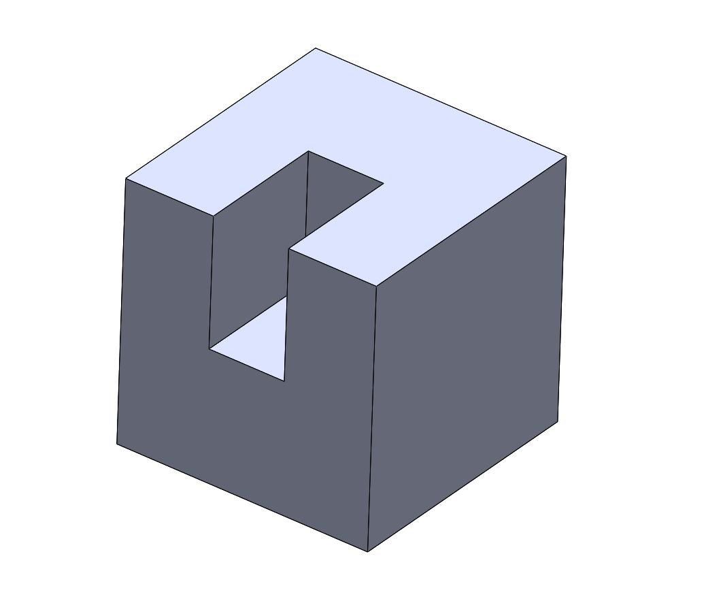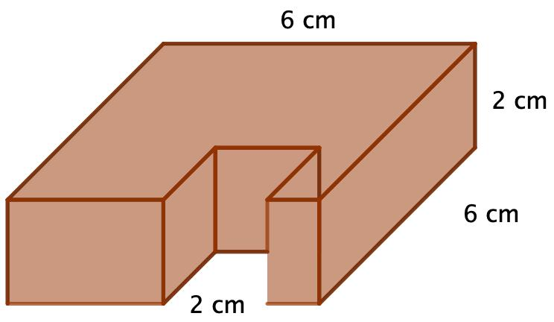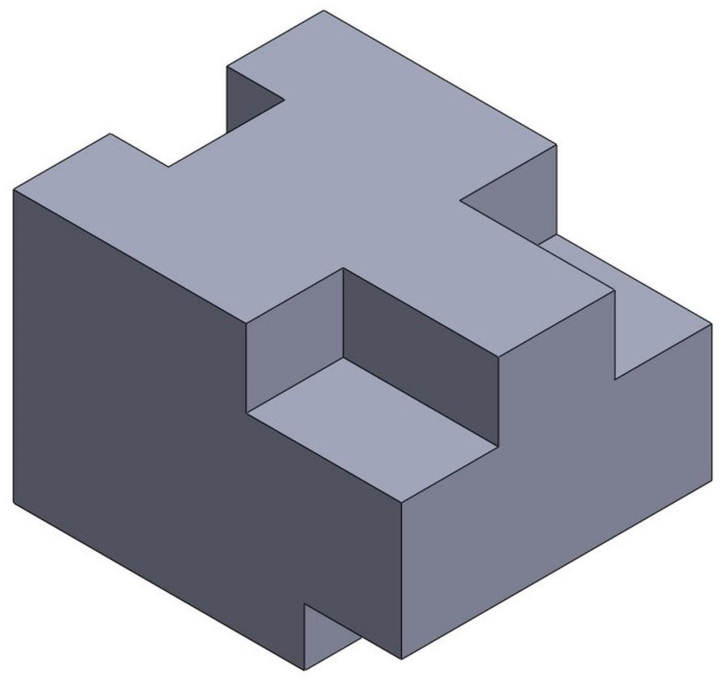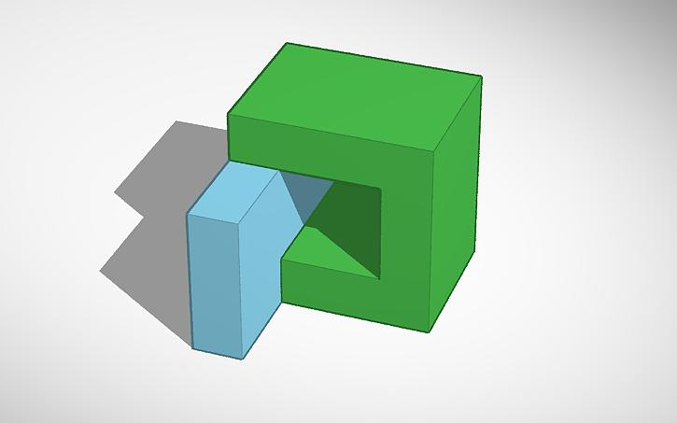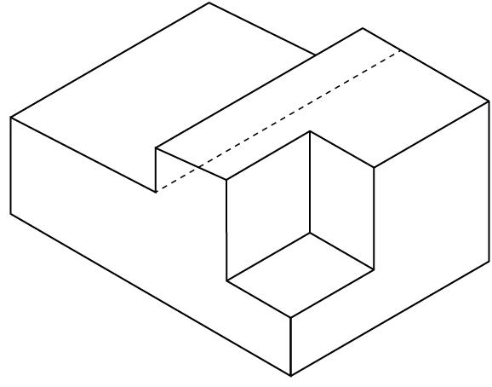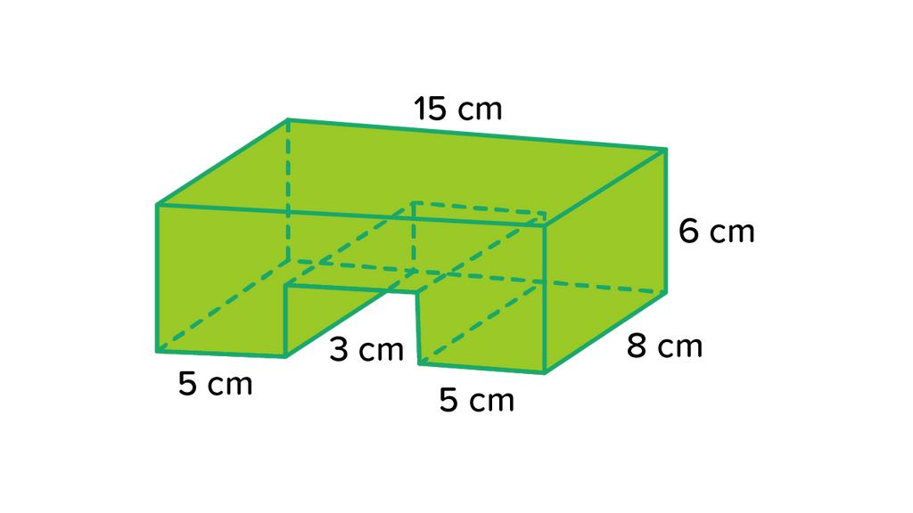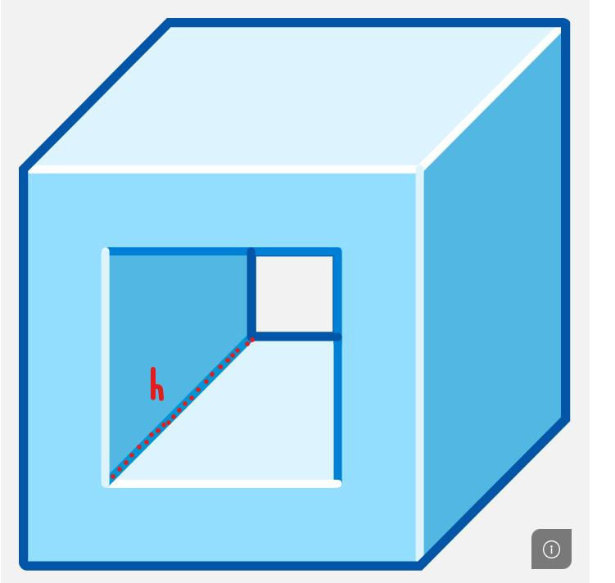
Created by removing a prism-shaped portion from an existing solid.
Examples:
- Rectangular prism with a rectangular notch.
- Cube with a smaller rectangular prism removed.
- Block with a stepped cutout.
- Prism with a triangular prism removed.

Cylinder-Based Subtraction
# Source: AI Source: Provided by: [Data Path: Persons Table -> ID Column: 1, Name_En Column: Motasem Essam] -> From: [ChatGPT] on [7/25/2026]
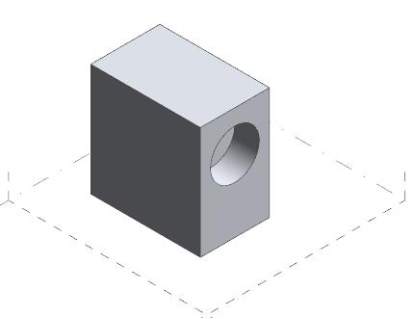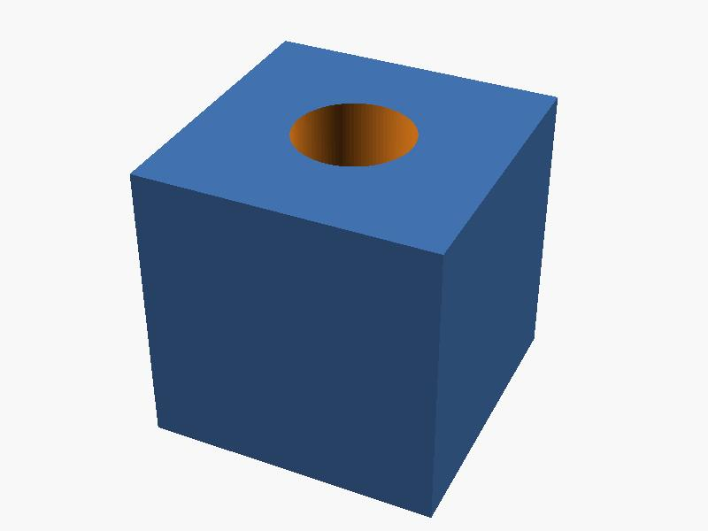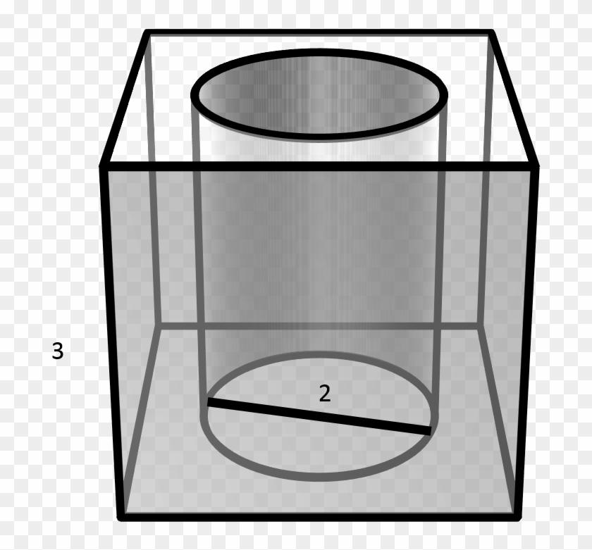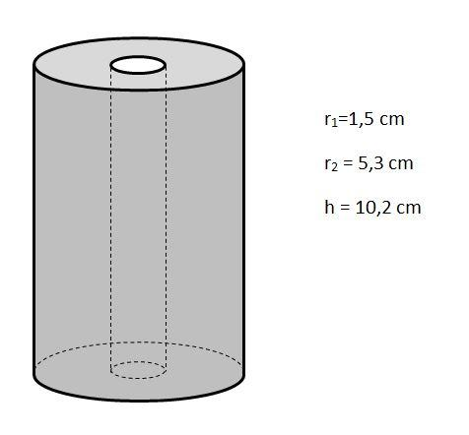
Created by removing a cylindrical portion from a solid.
Examples:
- Rectangular prism with a cylindrical hole.
- Cylinder with a smaller cylindrical cavity.
- Block with multiple cylindrical holes.
- Solid with a blind cylindrical bore.

Cone-Based Subtraction
# Source: AI Source: Provided by: [Data Path: Persons Table -> ID Column: 1, Name_En Column: Motasem Essam] -> From: [ChatGPT] on [7/25/2026]
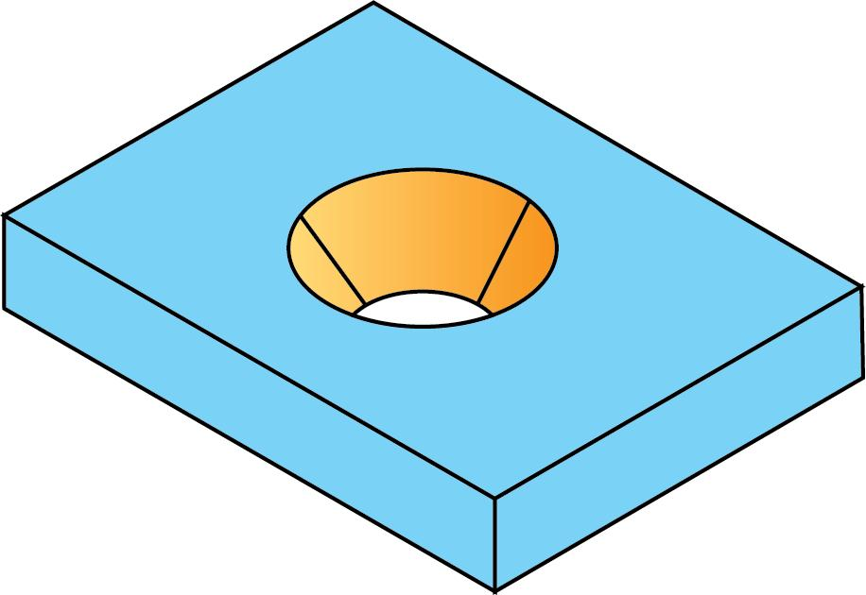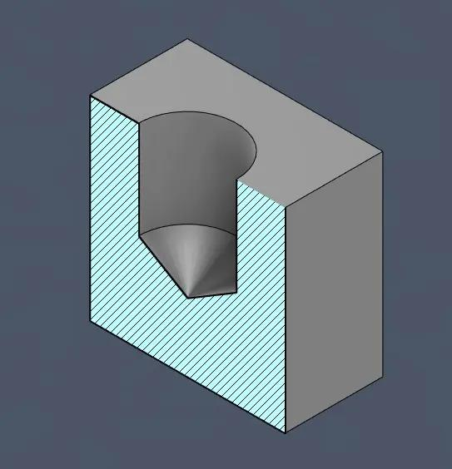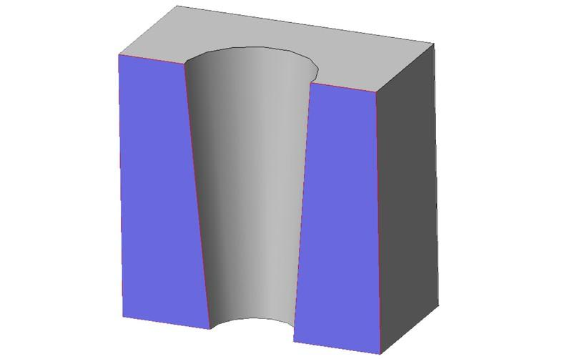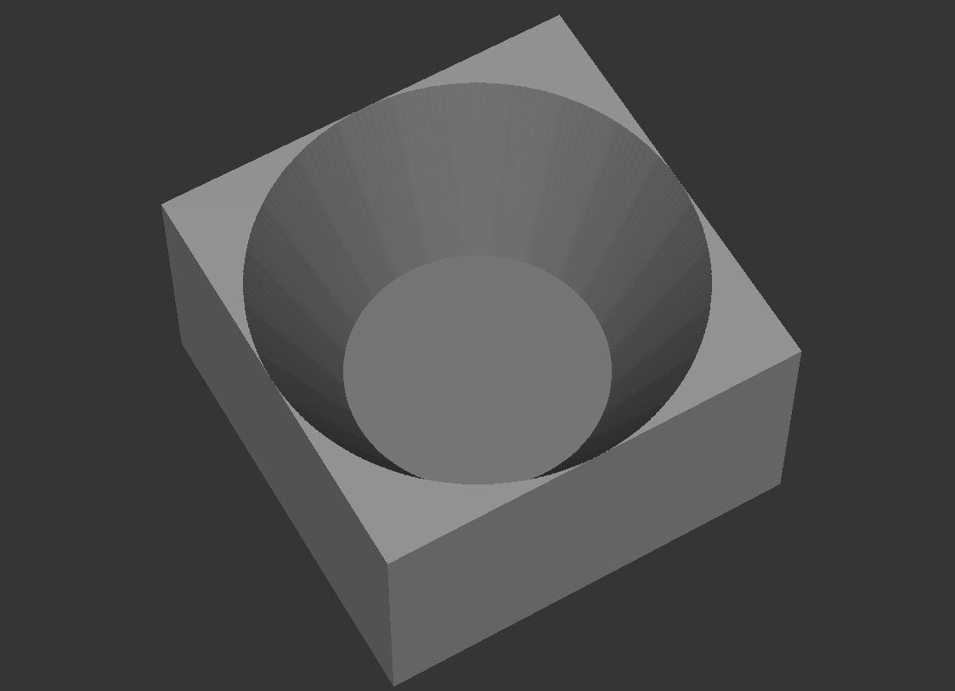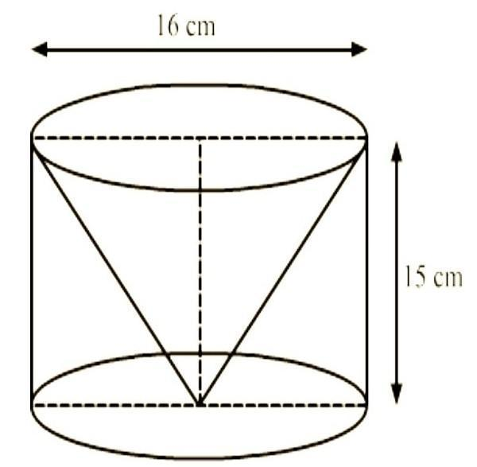
Created by removing a cone-shaped portion from an existing solid.
Examples:
- Cylinder with a conical cavity.
- Rectangular block with a conical depression.
- Solid with a conical hole.
- Cone-shaped cutout from a larger composite solid.

Pyramid-Based Subtraction
# Source: AI Source: Provided by: [Data Path: Persons Table -> ID Column: 1, Name_En Column: Motasem Essam] -> From: [ChatGPT] on [7/25/2026]
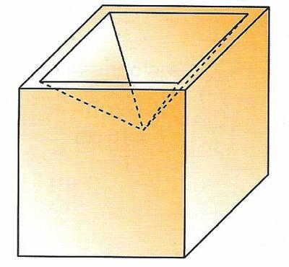
Created by removing a pyramid-shaped portion from a solid.
Examples:
- Cube with a square pyramidal cavity.
- Rectangular prism with a pyramidal cutout.
- Block with a triangular pyramid removed.
- Solid with multiple pyramidal cavities.

Sphere-Based Subtraction
# Source: AI Source: Provided by: [Data Path: Persons Table -> ID Column: 1, Name_En Column: Motasem Essam] -> From: [ChatGPT] on [7/25/2026]
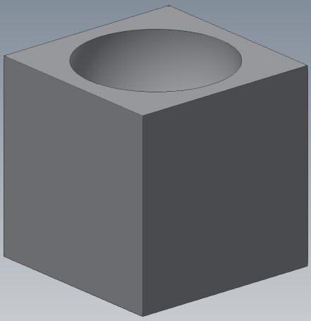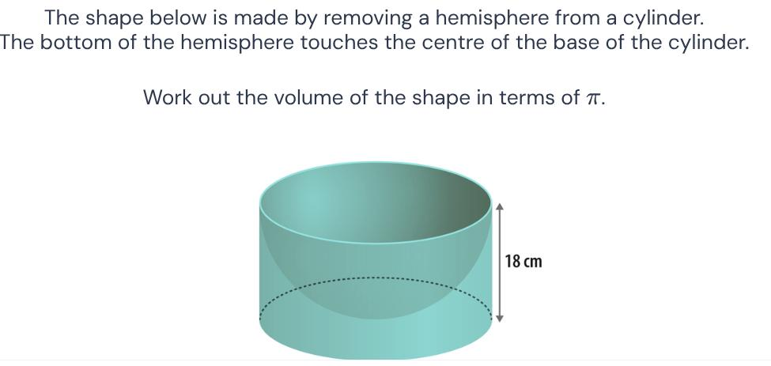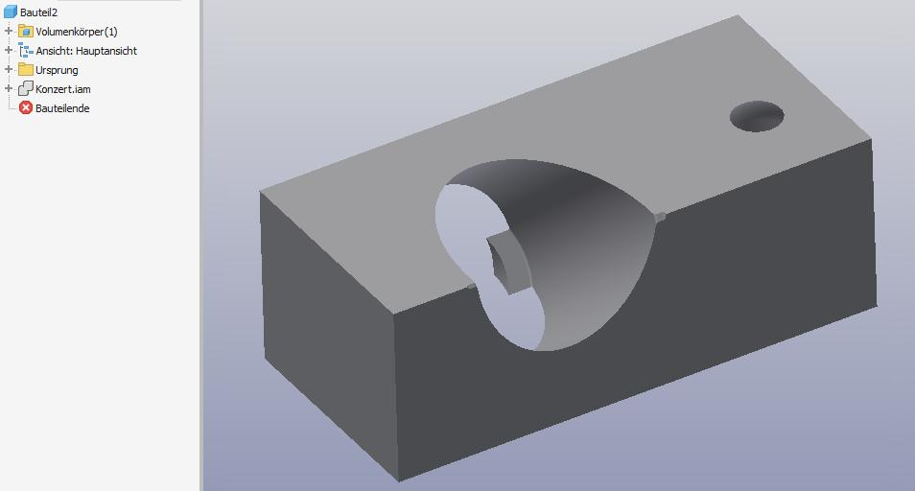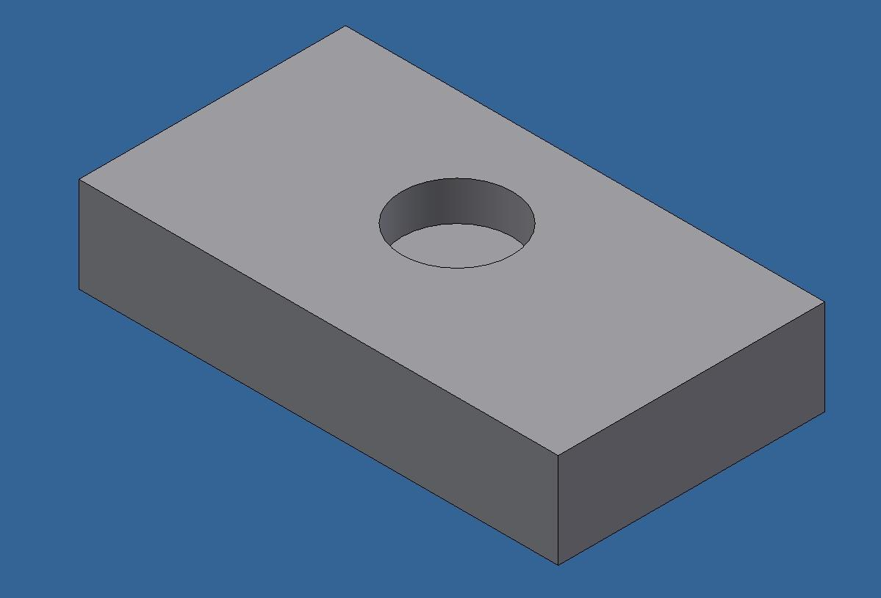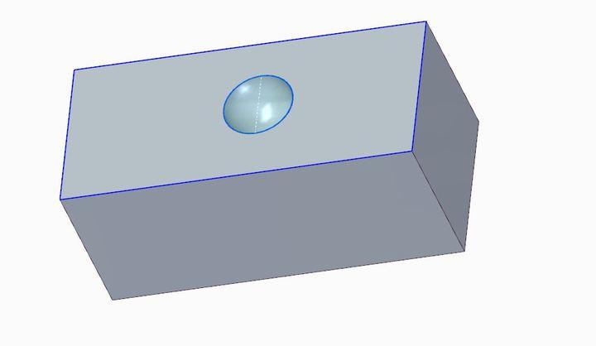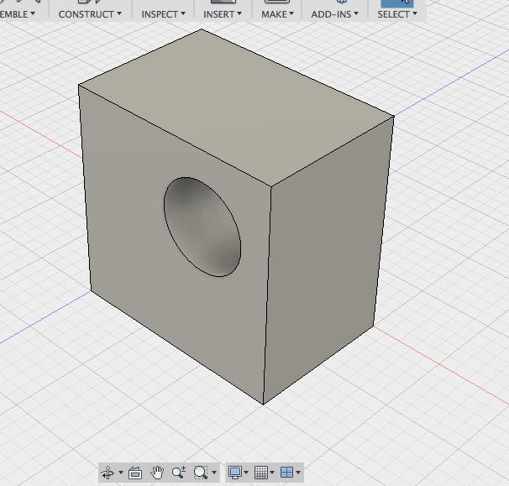
Created by removing a spherical or hemispherical portion from a solid.
Examples:
- Cube with a spherical cavity.
- Rectangular prism with a spherical hole.
- Cylinder with a hemispherical depression.
- Solid block with multiple spherical cavities.

Mixed-Shape Subtraction
# Source: AI Source: Provided by: [Data Path: Persons Table -> ID Column: 1, Name_En Column: Motasem Essam] -> From: [ChatGPT] on [7/25/2026]
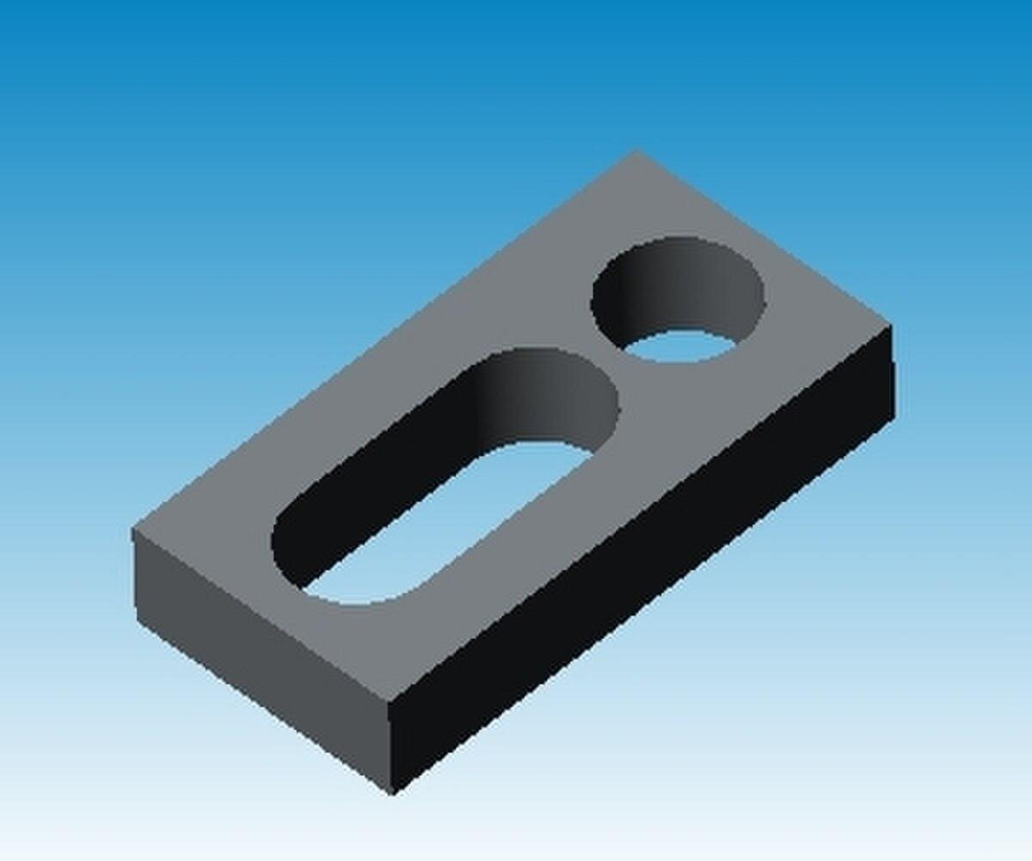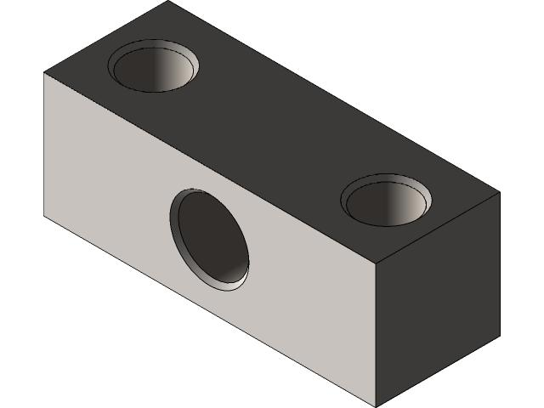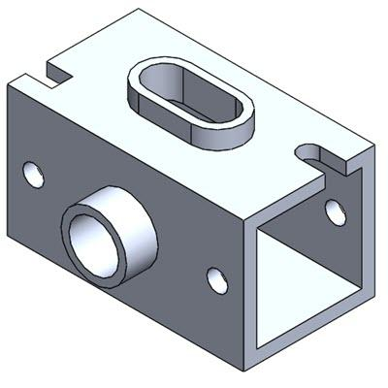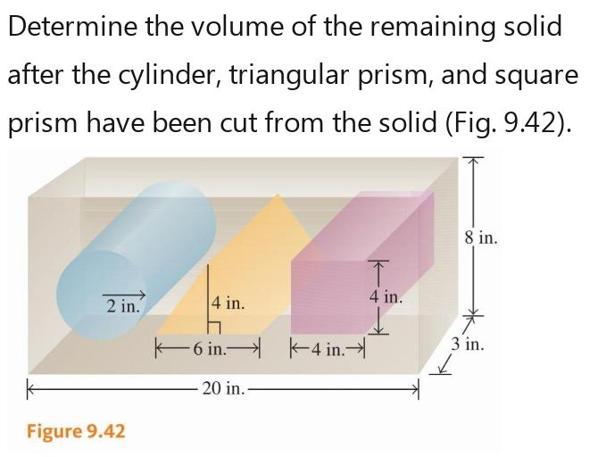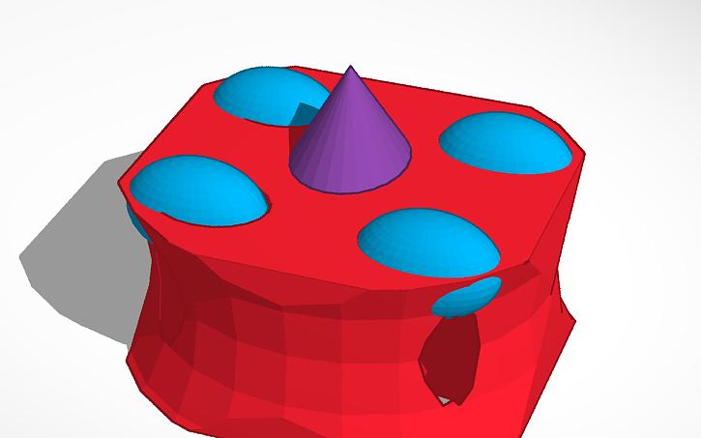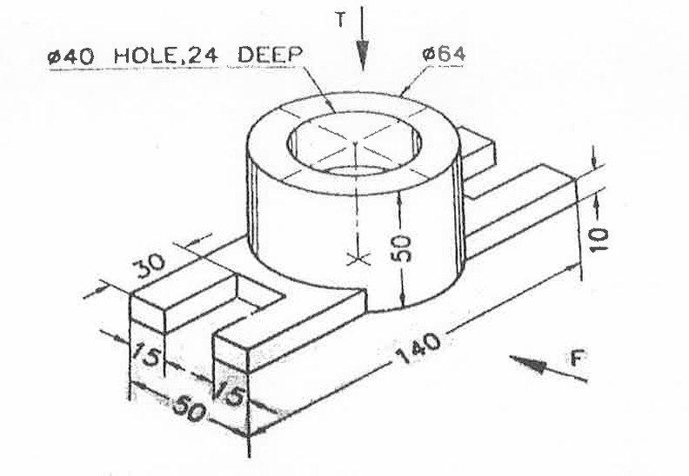
Created by removing portions with different geometric shapes from the same solid.
Examples:
- Rectangular prism with cylindrical and rectangular holes.
- Cylinder with conical and hemispherical cavities.
- Cube with spherical and cylindrical cutouts.
- Complex block with several differently shaped cavities.

Classification by Subtraction Method
# Source: AI Source: Provided by: [Data Path: Persons Table -> ID Column: 1, Name_En Column: Motasem Essam] -> From: [ChatGPT] on [7/25/2026]
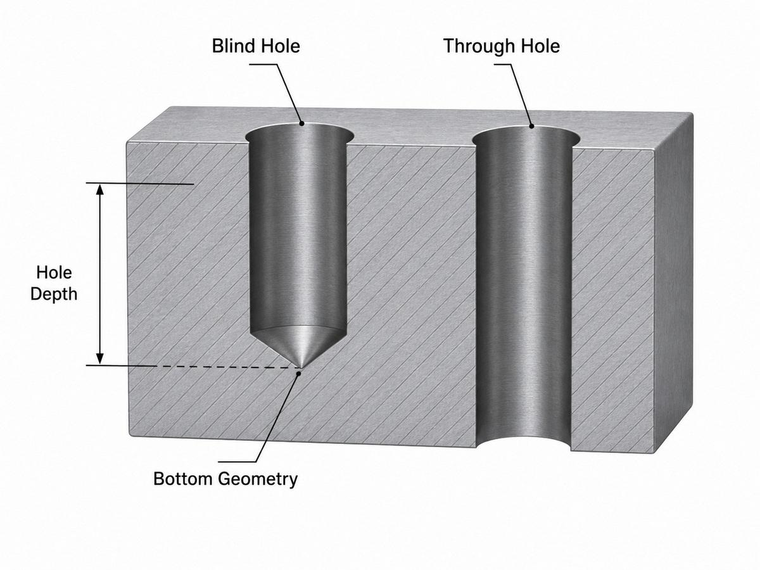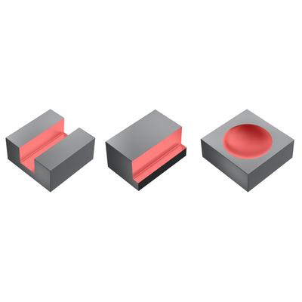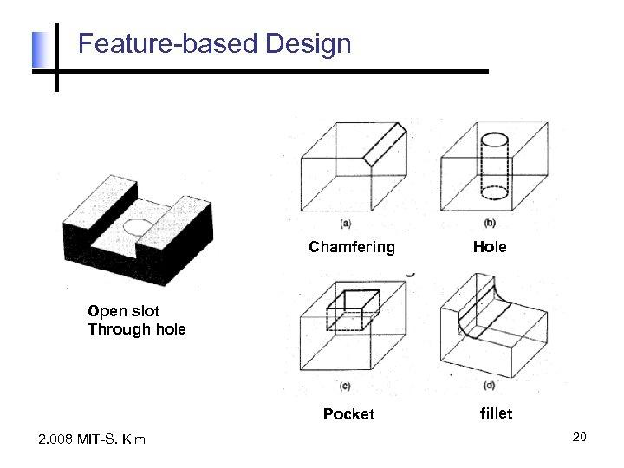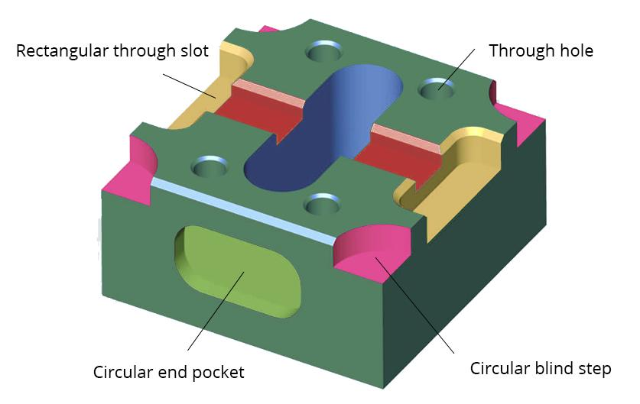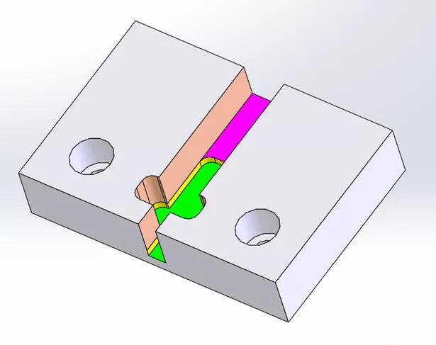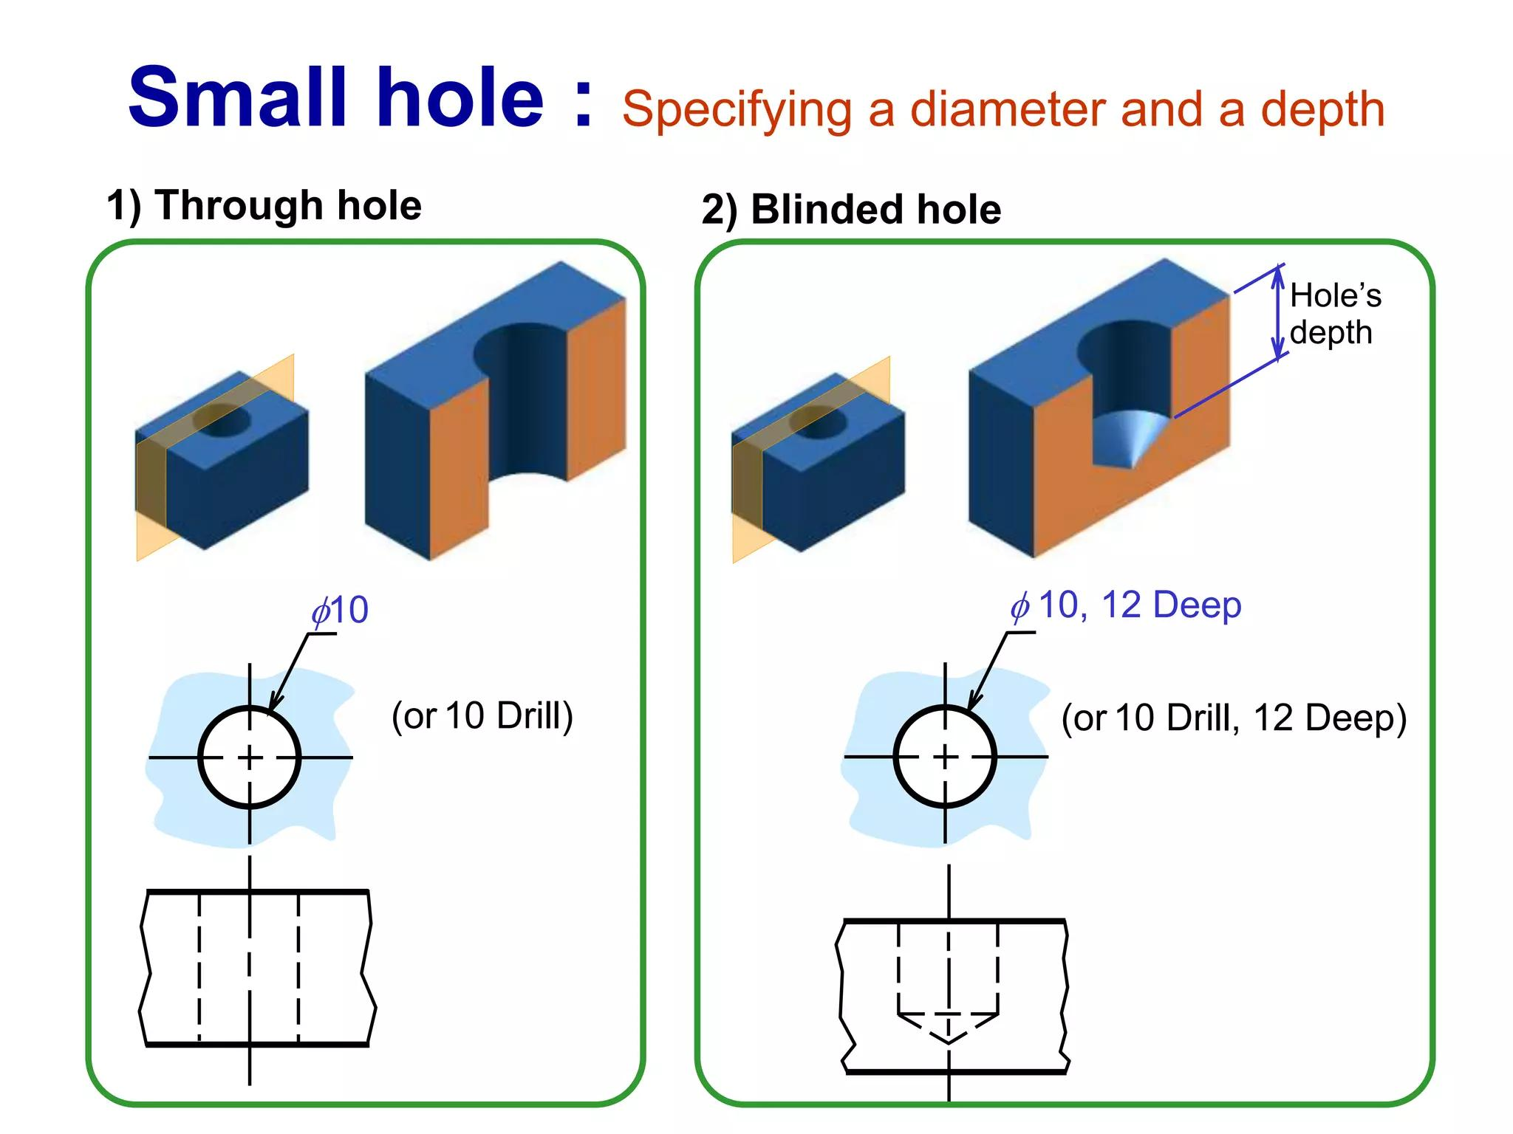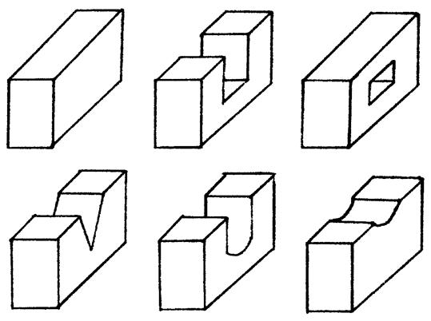
Composite solids formed by subtraction can also be classified according to how material is removed.
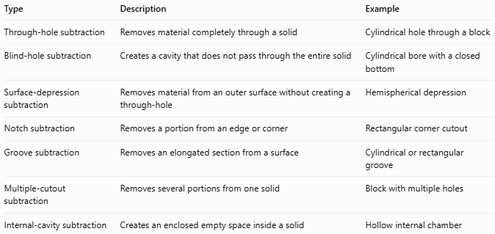
Type | Description | Example
Through-hole subtraction | Removes material completely through a solid | Cylindrical hole through a block
Blind-hole subtraction | Creates a cavity that does not pass through the entire solid | Cylindrical bore with a closed bottom
Surface-depression subtraction | Removes material from an outer surface without creating a through-hole | Hemispherical depression
Notch subtraction | Removes a portion from an edge or corner | Rectangular corner cutout
Groove subtraction | Removes an elongated section from a surface | Cylindrical or rectangular groove
Multiple-cutout subtraction | Removes several portions from one solid | Block with multiple holes
Internal-cavity subtraction | Creates an enclosed empty space inside a solid | Hollow internal chamber

Mathematical Properties and Formulas

Remaining Volume
# Source: AI Source: Provided by: [Data Path: Persons Table -> ID Column: 1, Name_En Column: Motasem Essam] -> From: [ChatGPT] on [7/25/2026]
For one removed portion:
$$\boxed{V_{remaining}=V_{original}-V_{removed}}$$
For multiple non-overlapping removed portions:
$$\boxed{V_{remaining}=V_{original}-∑_{i=1}^{n}V_{i}}$$
Where:
- $V_{original}$: Volume of the original solid.
- $V_{i}$: Volume of each removed portion.
- $n$: Number of removed portions.
Important: If removed portions overlap, their intersection must not be subtracted twice. The volume of their union must be calculated.

Volume of Common Removed Solids
# Source: AI Source: Provided by: [Data Path: Persons Table -> ID Column: 1, Name_En Column: Motasem Essam] -> From: [ChatGPT] on [7/25/2026]
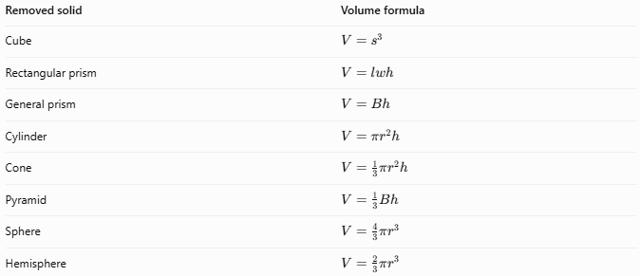
Removed solid | Volume formula
Cube | $$V=s^{3}$$
Rectangular prism | $$V=lwh$$
General prism | $$V=Bh$$
Cylinder | $$V=πr^{2}h$$
Cone | $$V=\frac{1}{3}πr^{2}h$$
Pyramid | $$V=\frac{1}{3}Bh$$
Sphere | $$V=\frac{4}{3}πr^{3}$$
Hemisphere | $$V=\frac{2}{3}πr^{3}$$

External Surface Area
# Source: AI Source: Provided by: [Data Path: Persons Table -> ID Column: 1, Name_En Column: Motasem Essam] -> From: [ChatGPT] on [7/25/2026]
Subtraction changes the external surface area because it may expose new surfaces inside the original solid.
For a simple through-hole, the surface area calculation generally involves:
- Removing the area of the opening from the original exterior surface.
- Adding the newly exposed internal lateral surface.
- Accounting for any additional exposed faces.
For example, a cylindrical hole passing completely through a rectangular prism creates a cylindrical internal surface.
There is no single universal surface-area subtraction formula; it depends on the geometry and position of the removed portion.

Worked Examples

Example 1: Rectangular Prism with a Cylindrical Hole
# Source: AI Source: Provided by: [Data Path: Persons Table -> ID Column: 1, Name_En Column: Motasem Essam] -> From: [ChatGPT] on [7/25/2026]
A cylindrical hole is drilled vertically through a rectangular prism.
Given:
- Length: $l=10$ cm
- Width: $w=8$ cm
- Height: $h=6$ cm
- Hole radius: $r=2$ cm
- Hole height: $h_{c}=6$ cm
Step 1: Calculate the original volume
$$V_{1}=lwh$$
$$V_{1}=10(8)(6)=480$$
Step 2: Calculate the removed cylindrical volume
$$V_{2}=πr^{2}h_{c}$$
$$V_{2}=π(2)^{2}(6)=24π$$
Step 3: Calculate the remaining volume
$$V_{remaining}=480-24π$$
$$\boxed{V_{remaining}≈404.60{ cm}^{3}}$$

Example 2: Cube with a Spherical Cavity
# Source: AI Source: Provided by: [Data Path: Persons Table -> ID Column: 1, Name_En Column: Motasem Essam] -> From: [ChatGPT] on [7/25/2026]
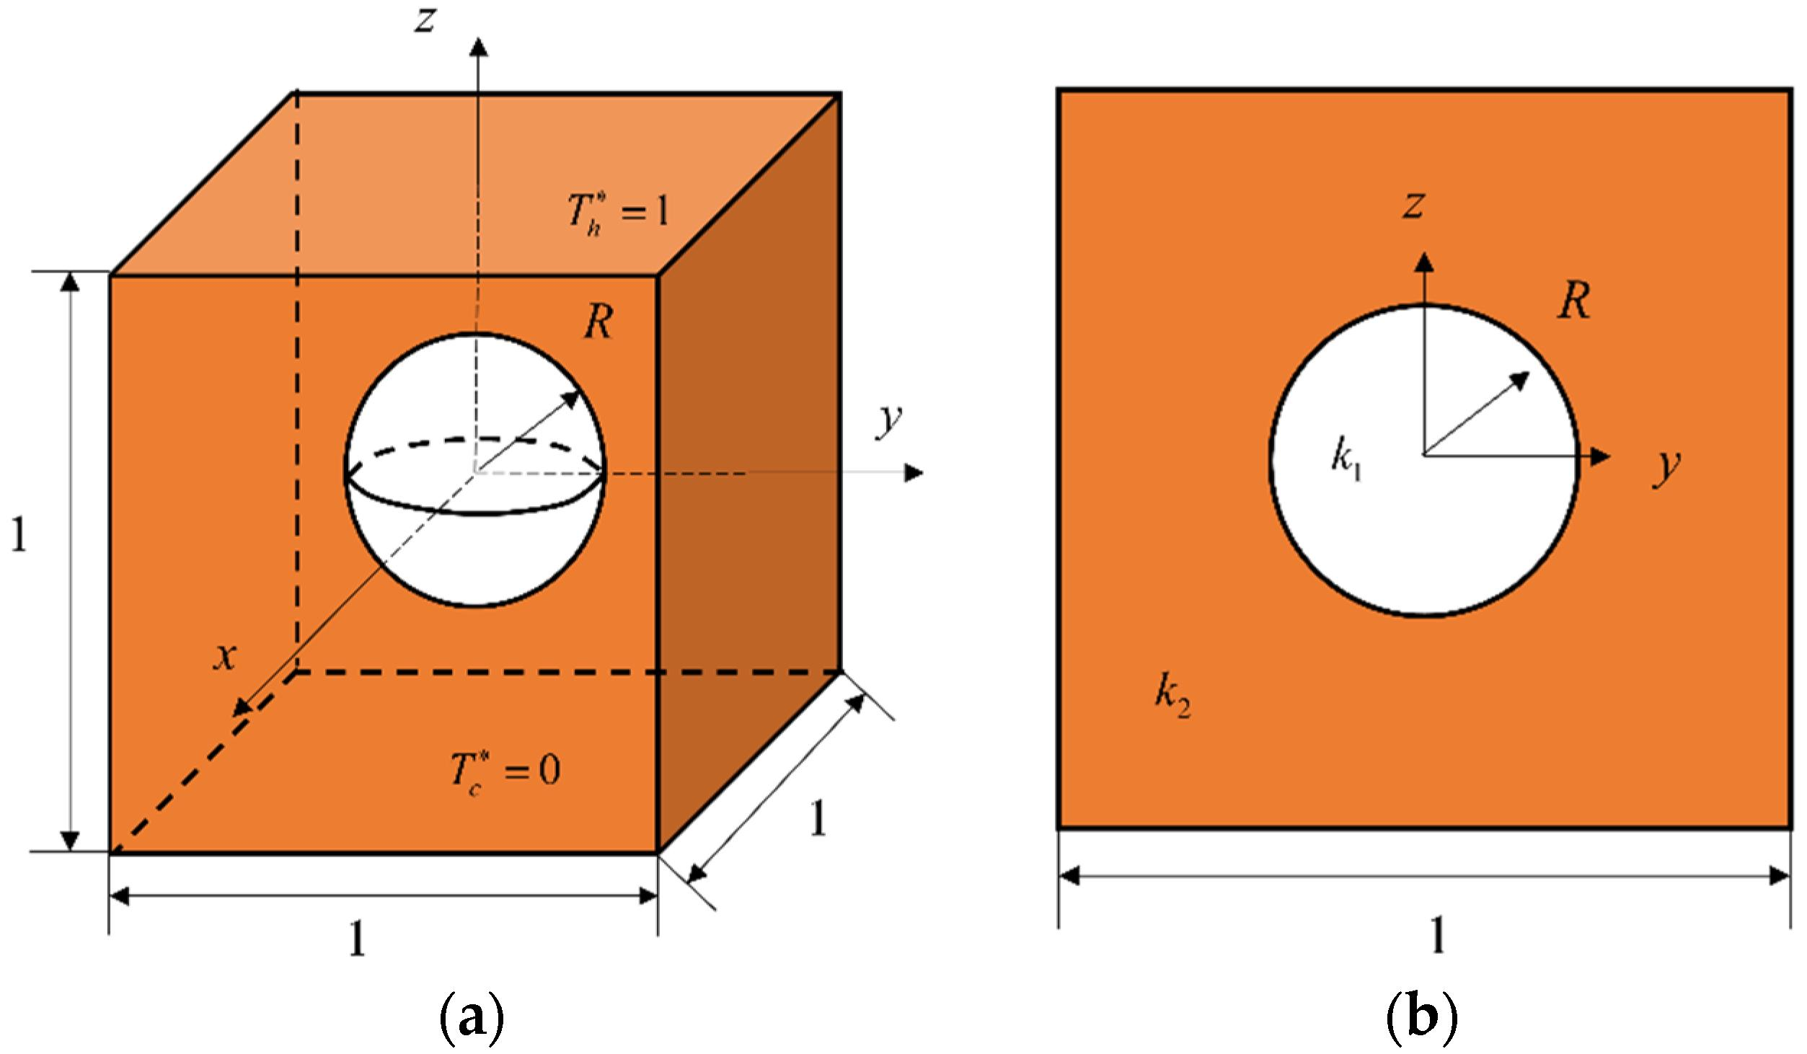
A spherical cavity is removed from a cube.
Given:
- Cube side length: $s=8$ cm
- Sphere radius: $r=3$ cm
Step 1: Calculate the cube volume
$$V_{1}=s^{3}$$
$$V_{1}=8^{3}=512$$
Step 2: Calculate the removed spherical volume
$$V_{2}=\frac{4}{3}πr^{3}$$
$$V_{2}=\frac{4}{3}π(3)^{3}=36π$$
Step 3: Calculate the remaining volume
$$V_{remaining}=512-36π$$
$$\boxed{V_{remaining}≈398.90{ cm}^{3}}$$

Important Characteristics
# Source: AI Source: Provided by: [Data Path: Persons Table -> ID Column: 1, Name_En Column: Motasem Essam] -> From: [ChatGPT] on [7/25/2026]
- Created by removing one or more portions from an existing solid.
- The removed portions may be regular geometric solids.
- The remaining solid may contain cavities, holes, grooves, or notches.
- The remaining volume is generally smaller than the original volume.
- The removed portions may have identical or different shapes.
- Subtraction can create new internal and external surfaces.
- The resulting solid may have a complex boundary.
- Overlapping removed portions require careful volume calculations.

Comparison with Other Types of Composite Solids
# Source: AI Source: Provided by: [Data Path: Persons Table -> ID Column: 1, Name_En Column: Motasem Essam] -> From: [ChatGPT] on [7/25/2026]
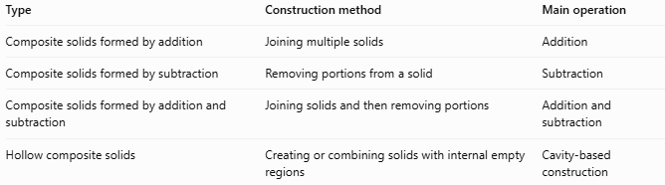
Type | Construction method | Main operation
Composite solids formed by addition | Joining multiple solids | Addition
Composite solids formed by subtraction | Removing portions from a solid | Subtraction
Composite solids formed by addition and subtraction | Joining solids and then removing portions | Addition and subtraction
Hollow composite solids | Creating or combining solids with internal empty regions | Cavity-based construction

Applications
# Source: AI Source: Provided by: [Data Path: Persons Table -> ID Column: 1, Name_En Column: Motasem Essam] -> From: [ChatGPT] on [7/25/2026]
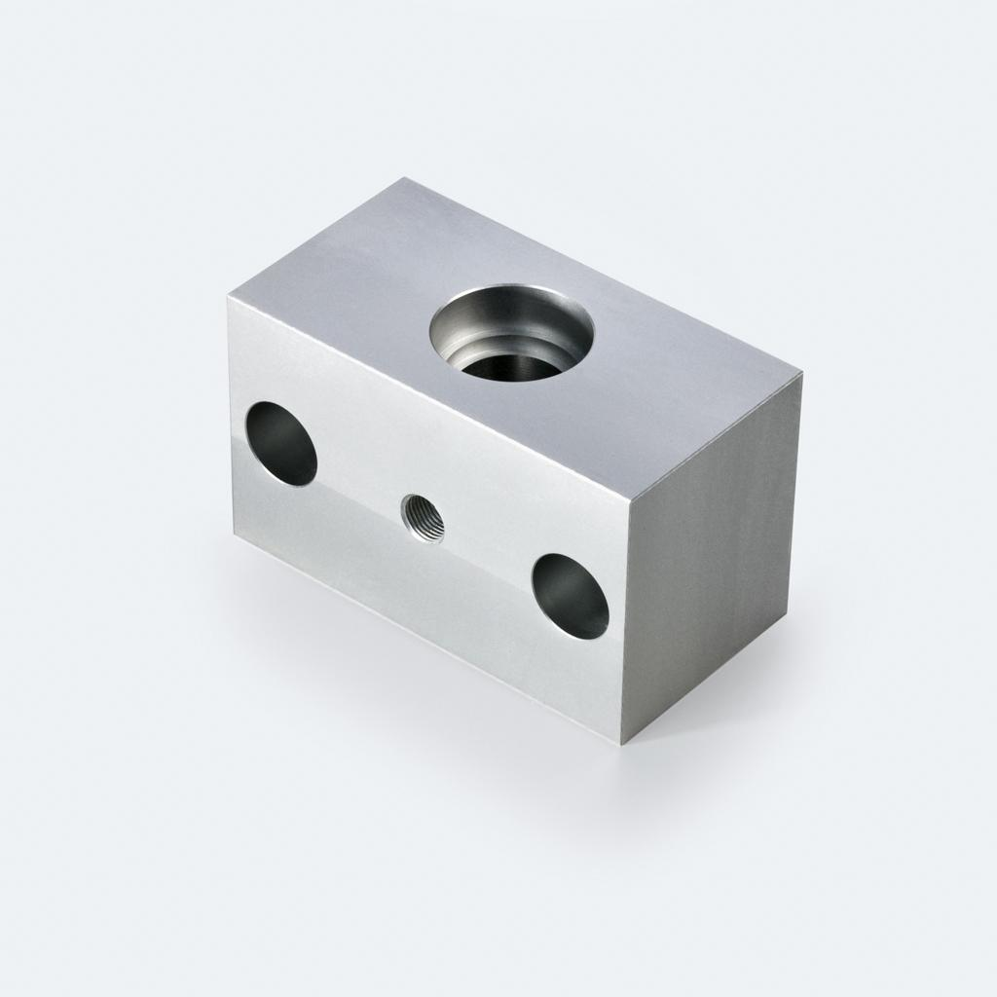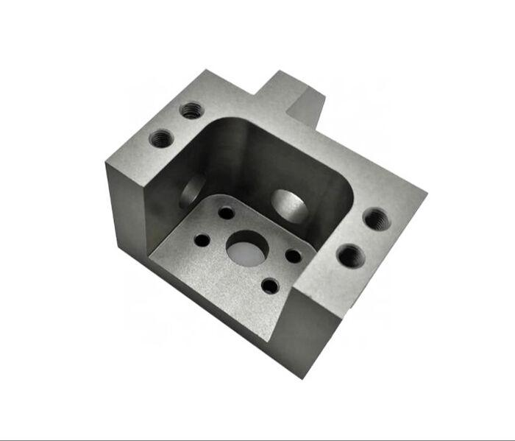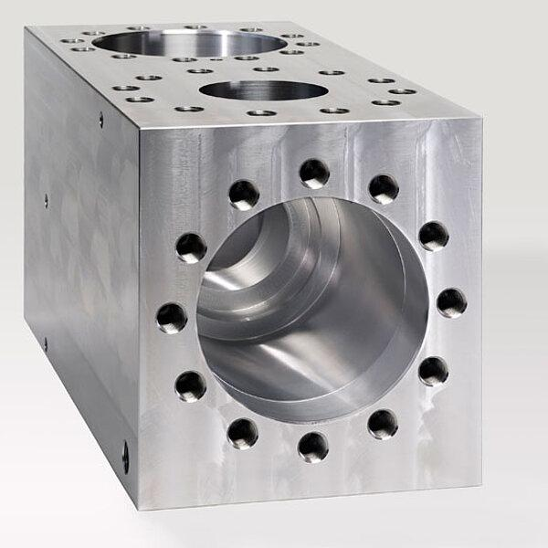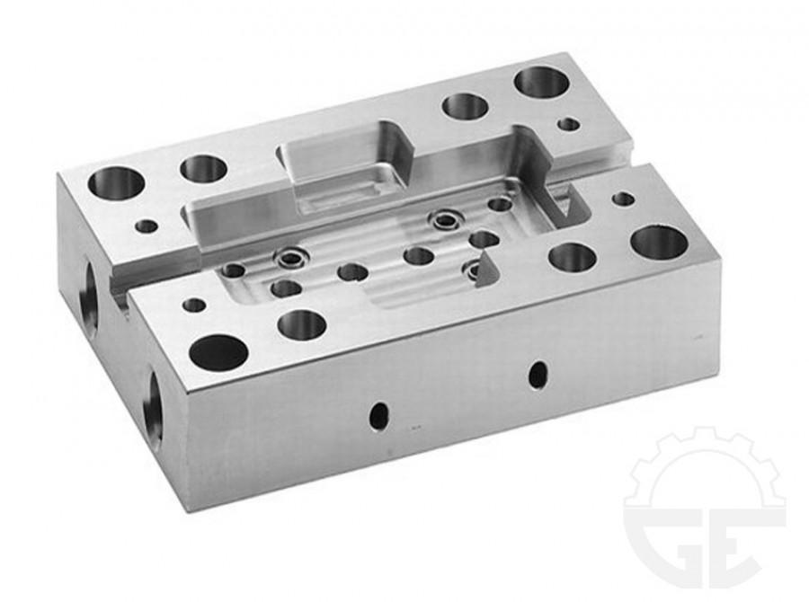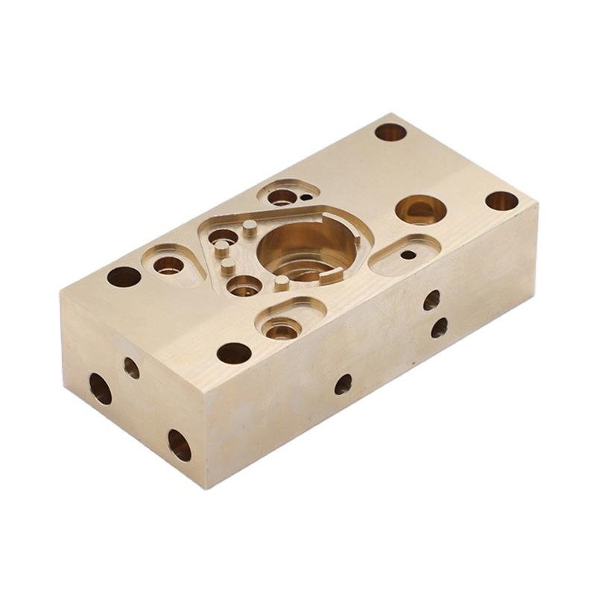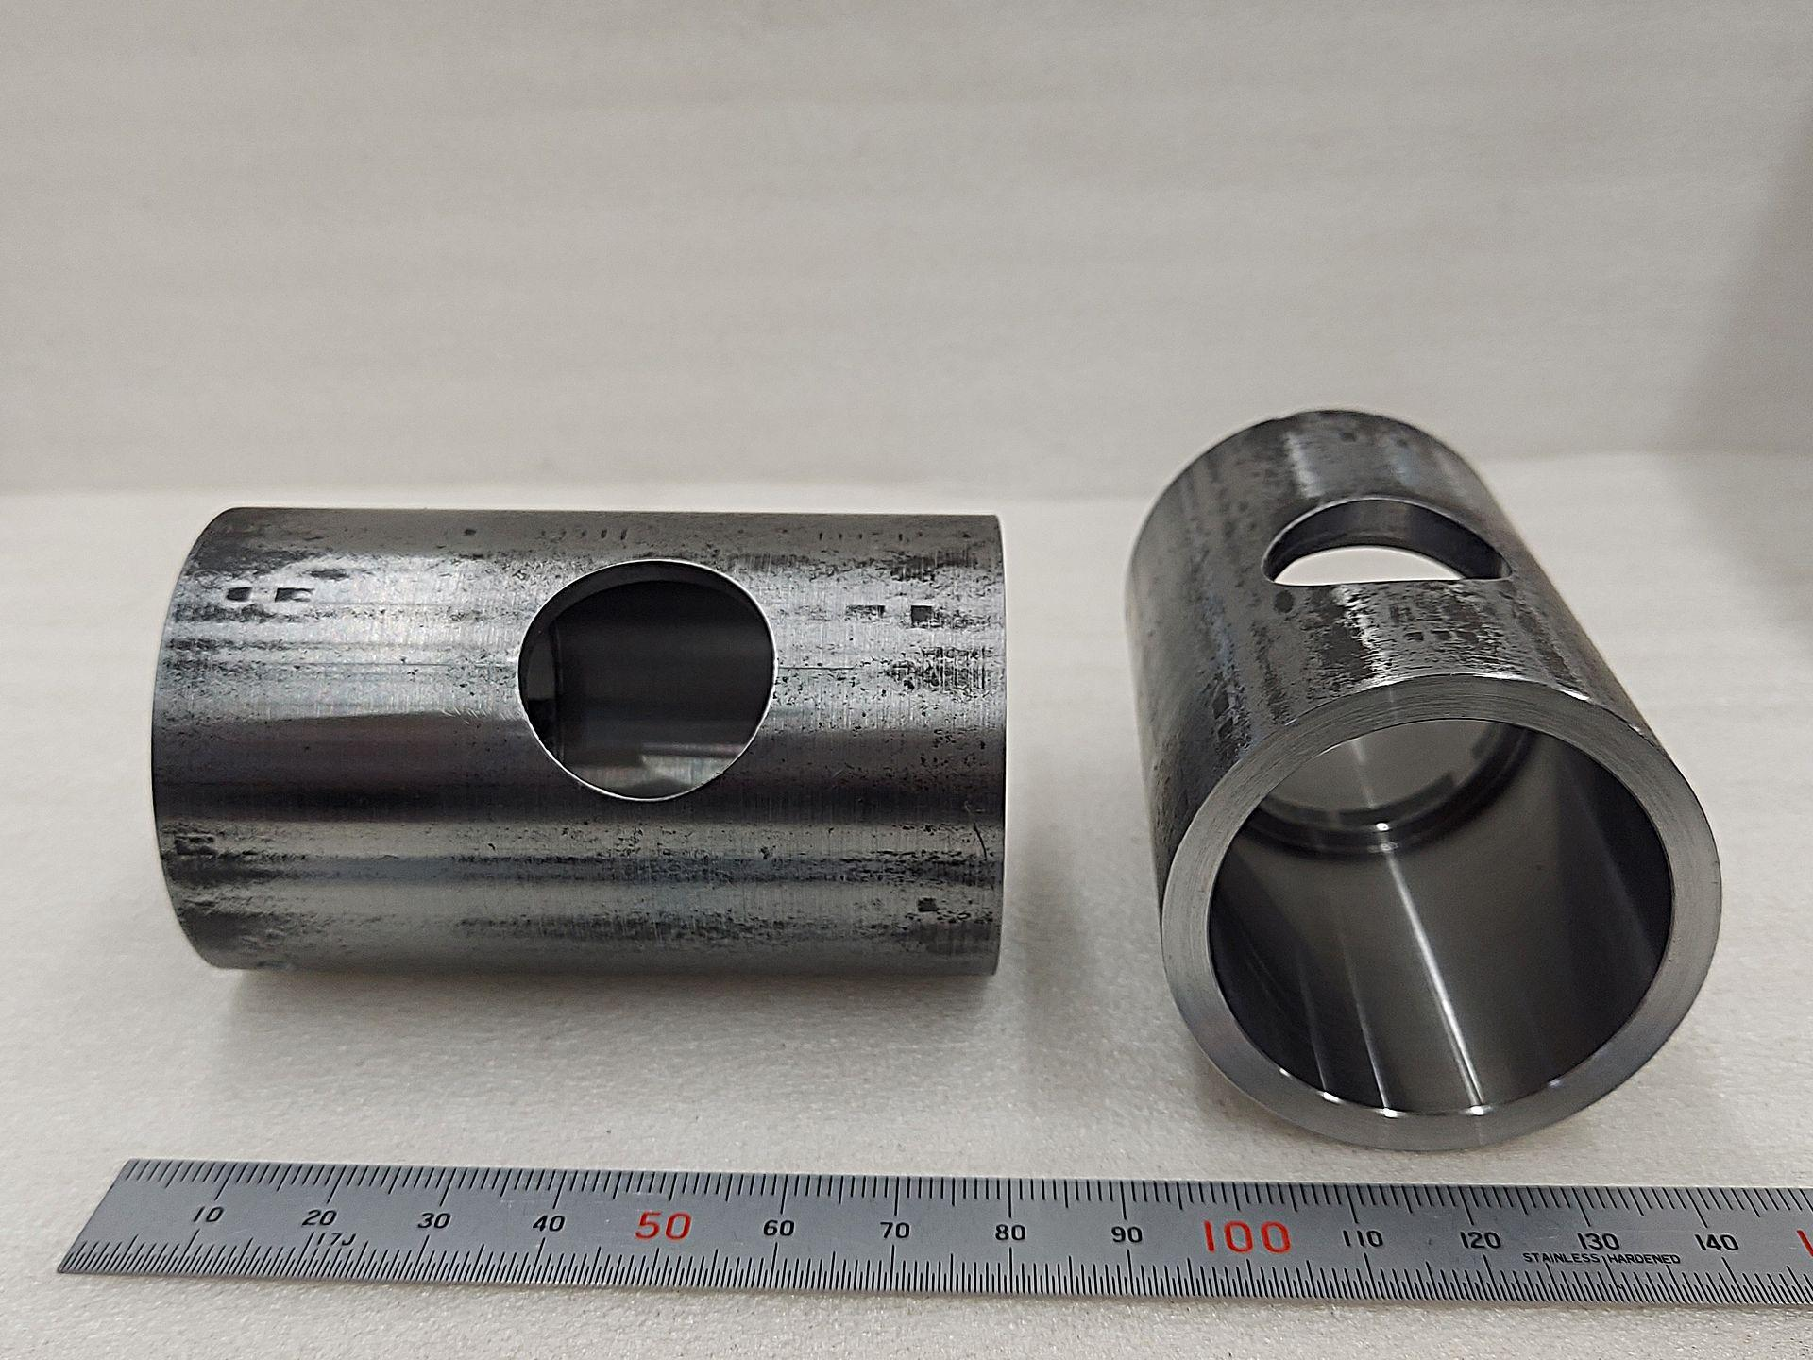
- Mechanical engineering: Designing components with drilled holes, grooves, and cavities.
- Manufacturing: Machining materials by milling, drilling, and cutting.
- Architecture: Designing buildings with openings, recesses, and structural cutouts.
- Construction: Creating channels, passages, and openings in solid structures.
- Product design: Modeling objects with internal chambers and recessed surfaces.
- Computer-aided design (CAD): Using Boolean difference operations to remove geometric regions from 3D models.

Key Points
# Source: AI Source: Provided by: [Data Path: Persons Table -> ID Column: 1, Name_En Column: Motasem Essam] -> From: [ChatGPT] on [7/25/2026]
- Composite solids formed by subtraction are created by removing material from an existing solid.
- The removed portions may be cylinders, cones, spheres, prisms, or other shapes.
- The remaining volume is calculated by subtracting the removed volume.
- Through-holes, blind holes, grooves, and cavities are common subtraction features.
- Internal and newly exposed surfaces must be considered when calculating surface area.
- Overlapping removed portions must not be counted more than once.

Conclusion
# Source: AI Source: Provided by: [Data Path: Persons Table -> ID Column: 1, Name_En Column: Motasem Essam] -> From: [ChatGPT] on [7/25/2026]
Composite solids formed by subtraction are three-dimensional geometric objects created by removing one or more portions from an existing solid. The resulting shapes may contain holes, cavities, grooves, notches, and other cutouts. They are important in geometry, mechanical engineering, manufacturing, architecture, and computer-aided design.

